# 

# EE463 Static Power Conversion I

# Term Project Final Report

## Volt Motors

## Mehmet Emre DOĞAN – 2374825

## Gamze ÇELİK – 2304327

## Ömer ŞEN – 2305415

## Introduction

In this project, a DC Motor Drive will be designed and implemented. The drive will run a DC motor when it is supplied by an AC source. In this report, aimed bonuses will be provided initially since the aims directs the topology. Then, Topology will be provided, and necessary simulation results will be given. Next, physical implementation work that has been done so far will be showed.

## Targeted Bonuses

### Tea Bonus

One of the aimed bonuses it that providing 2kW for 5 minutes to boil a water and make an glass of hot tea.

### PCB Bonus

An implementation of the system to a PCB is planned for not only the bonus points but also for building more robust system.

### Efficiency Bonus

One of the goals is that constructing the most efficient circuit that fulfills the function. However, the bonus is not only depending on the circuit but also depends on the other groups circuits. Therefore, making the system as efficient as possible is the goal at that point.

### Industrial Design Bonus

In order to protect the system from the outside impacts and crushes, it will be covered by a case.

### Single Supply Bonus

The system is designed to supply only with a one AC source. Rest of the voltage level(s) will be obtained by inside converters.

### Closed-Loop Voltage/Current Control Bonus

In order to protect the components from the high current, a closed feedback loop will be implemented by a current sensor.

### Closed-Loop Speed Control Bonus

In order to obtain the speed of the motor and construct a speed control loop, an infrared sensor will be utilized.

### Four-Quadrant Bonus

To operate in all the quadrants, 4 MOSFETs will be driven by 3 isolated drivers and OpAmp control.

## Topology

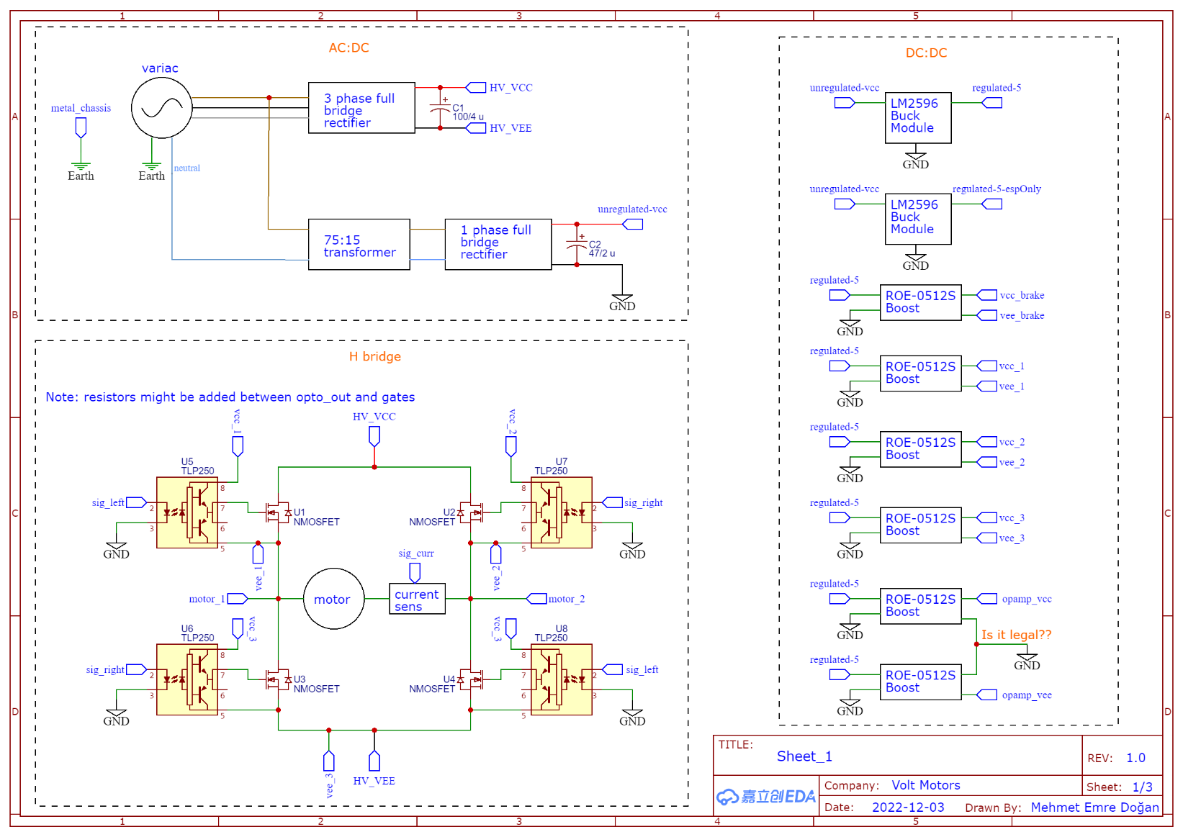

Figure 1: First Sheet of Topology

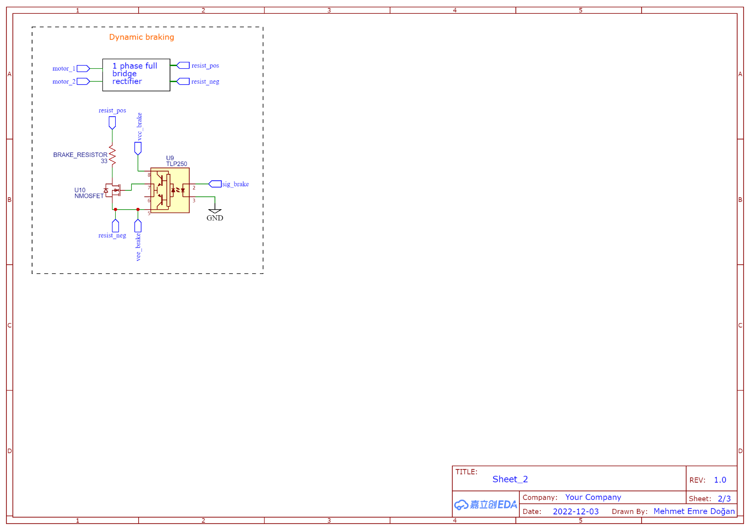

Figure 2: Second Sheet of Topology

Due to ease of usage of three phase full bridge rectifier + buck converter topology compared to other two topologies, three phase full bridge rectifier + buck converter is chosen as can be seen from the Figure 3. Moreover, the team is more experienced with the buck converter, which is another reason to choose buck converter topology. Also, implementing a topology which works in four of the quadrants, which is a determined feature by the team, would be very difficult by using thyristor. Therefore, H bridge topology is chosen to operate in four of the quadrants.

In order to supply the system with only one voltage source several converters are added to the topology, which can be seen from the Figure 1. Also, a transformer will be placed in the topology to provide required voltage level to the control circuitry. Output of the transformer will be rectified by a single-phase rectifier. After filtering, the closed loop buck converter which comes next will provide 5VDC output voltage.

Speed control feedback loop will be implemented by software that functions as PID. Input signal of the PID controller will be taken with infrared sensor.

Current control will be implemented by current sensor which will be connected in series to the armature terminals.

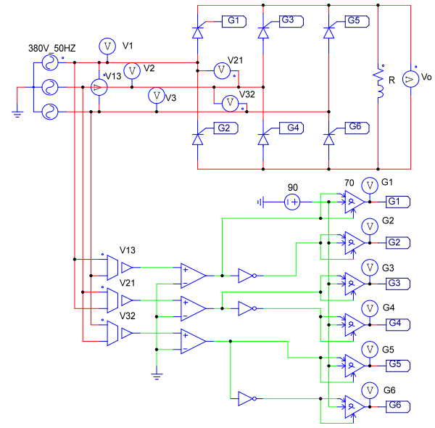

Figure 3: Thyristor Rectifier Circuit [1]

## Simulation Results

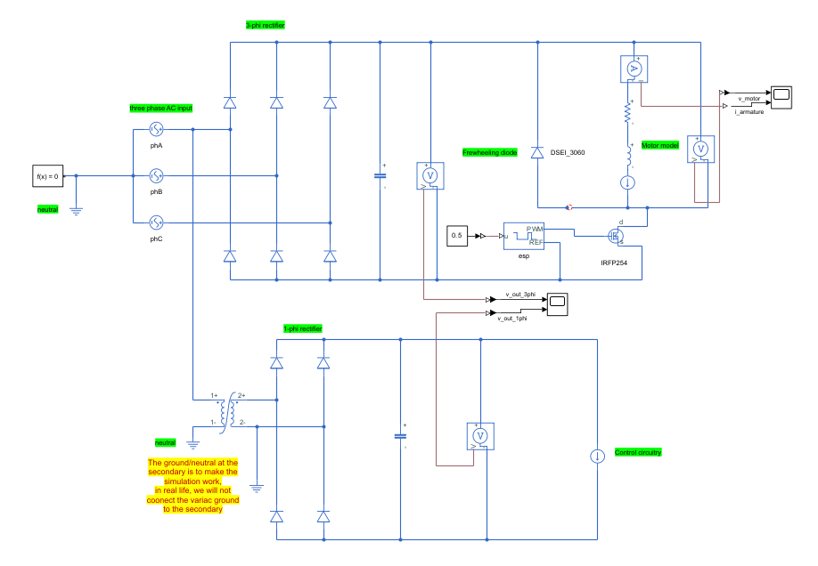

Figure 4: Simulation Circuitry

Basic purpose of the simulation is obtaining component ratings. The most important issue with the H bridge is determining the driving algorithm of the H bridge, which is hard to simulate in Simulink. As a result, H bridge is not implemented in Simulink.

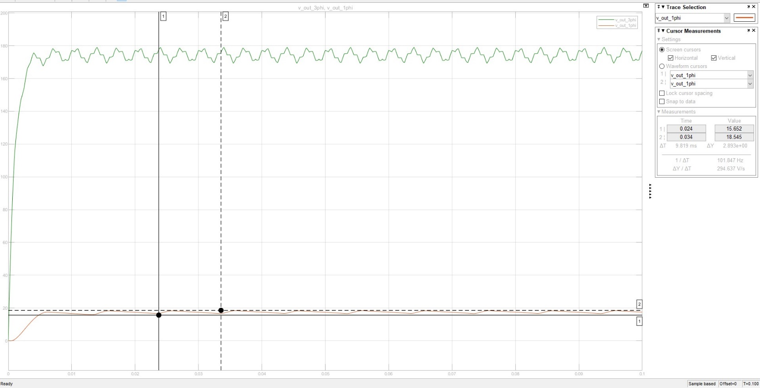

Figure 5: Control Circuitry Input Voltage

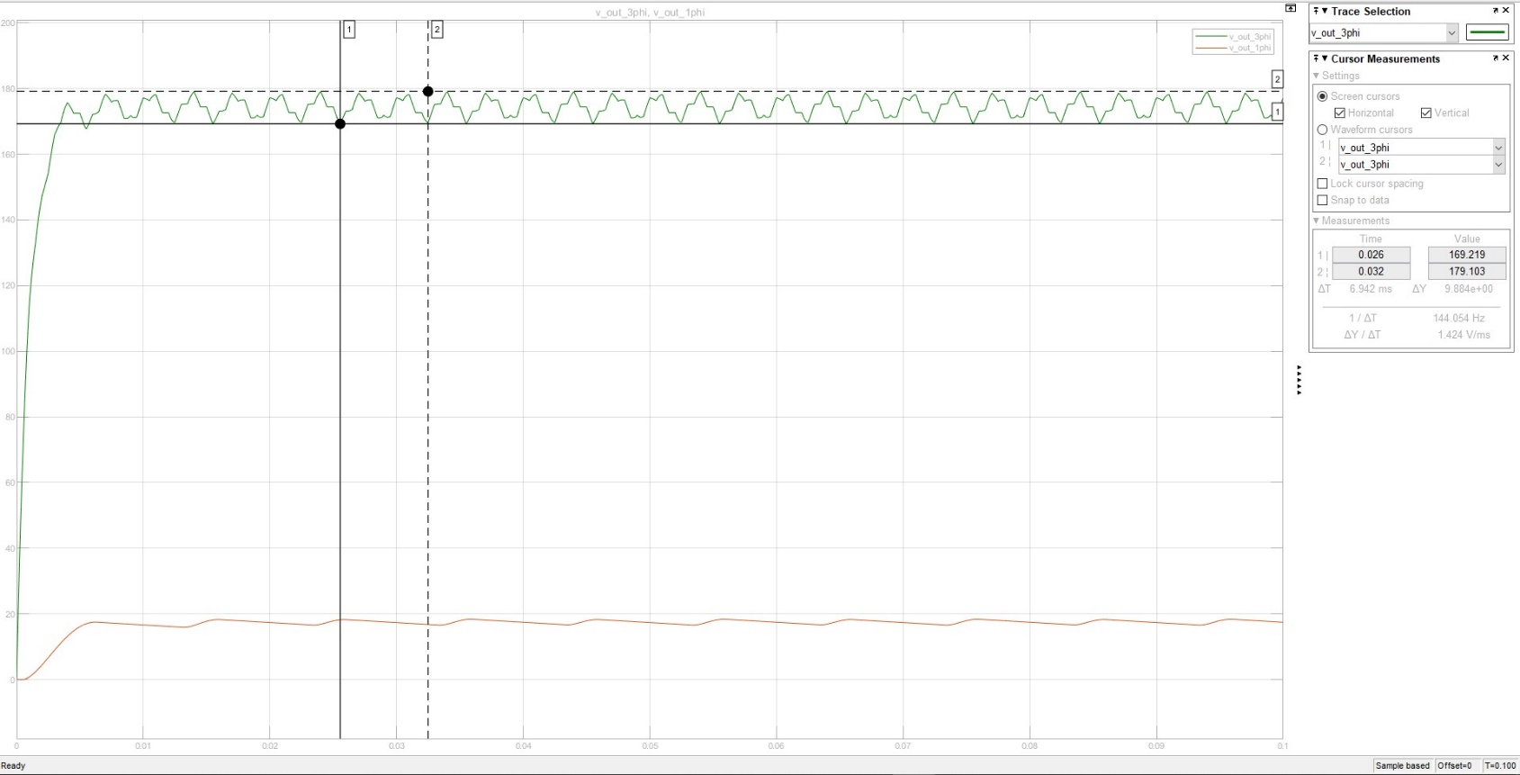

Figure 6: Motor Terminal Voltage Before PWM Signal

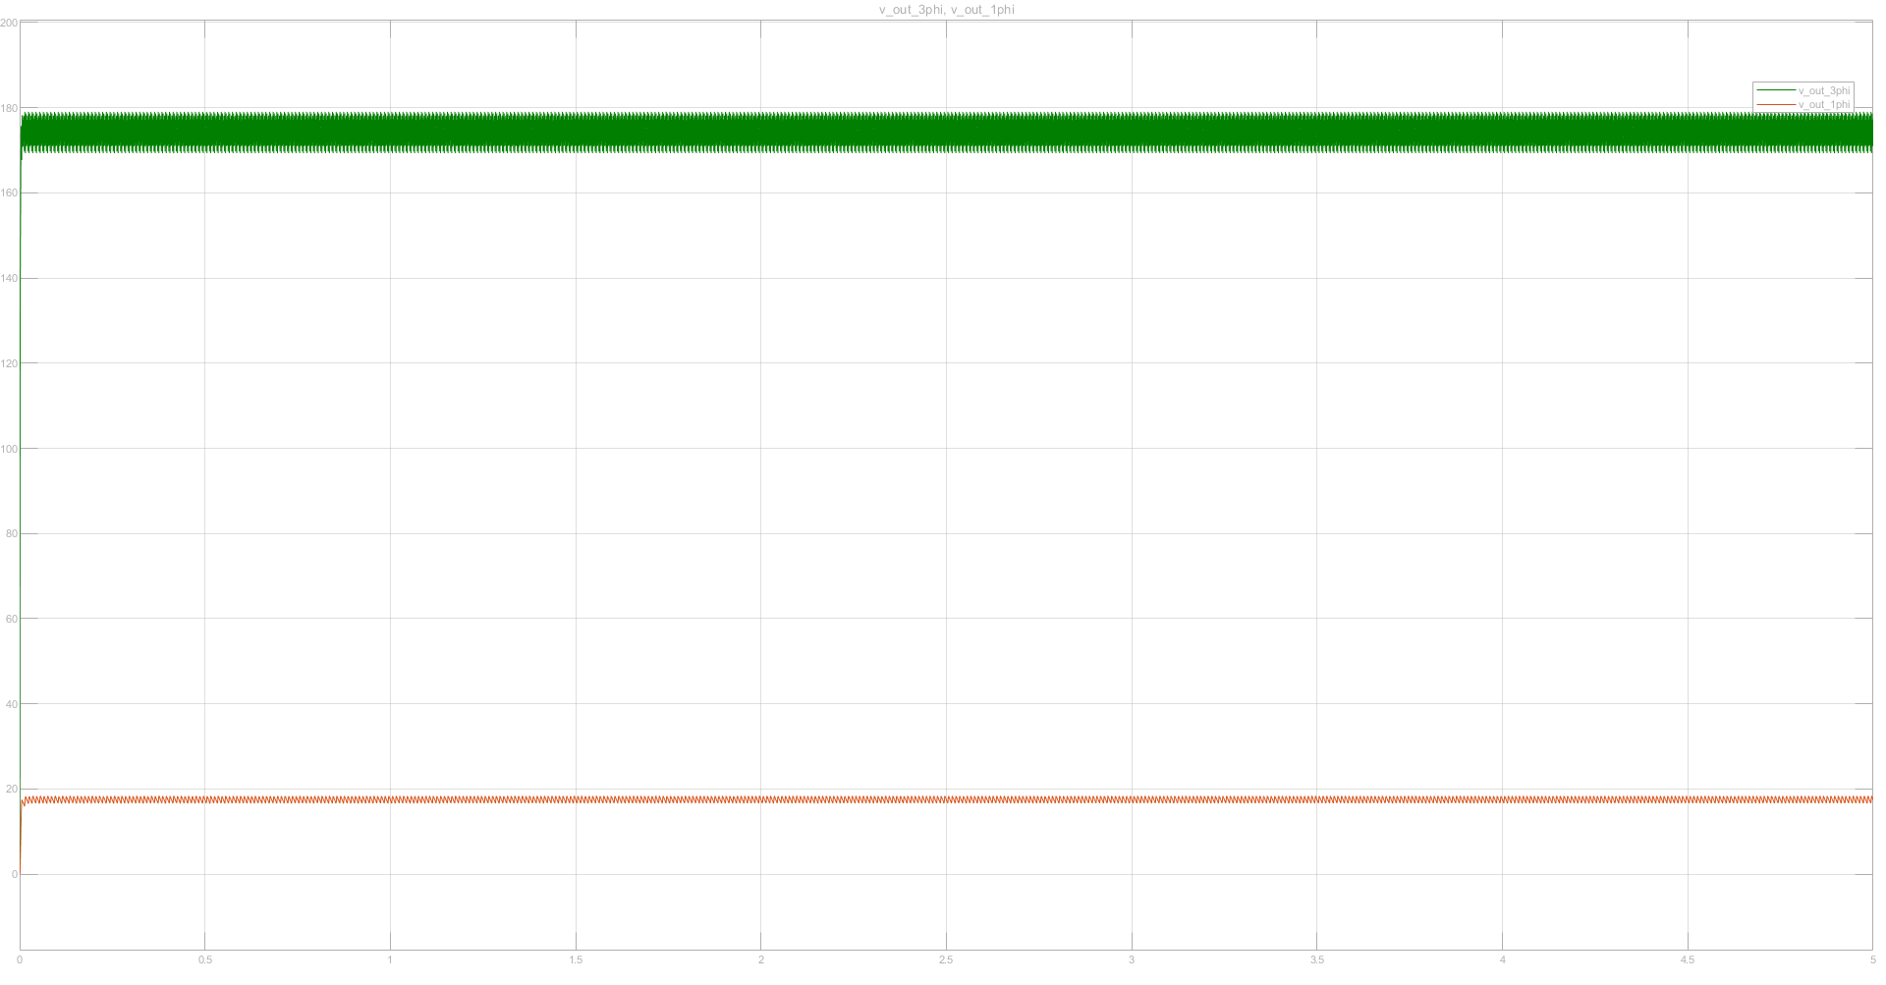

Figure 7: Stability Simulation of Rectifiers

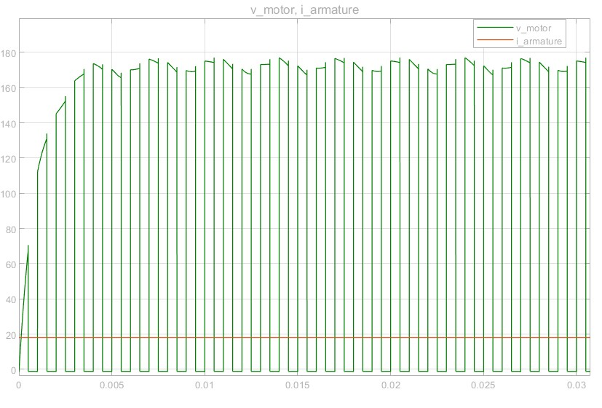

Figure 8: Terminal Rating of DC Motor After PWM Signal

## Component Selection

### Matlab Calculations

Base Calculation

clearvars

format shortEng

syms v_ln

vDc = (3*sqrt(6)/pi)*v_ln

vDc =



vDcWanted = 180

vDcWanted =

180.0000e+000

vln = double(solve(vDc == vDcWanted))

vln =

76.9530e+000

vll = vln*sqrt(3)

vll =

133.2865e+000

% the line-to-neutral voltage must be adjusted to 77 V RMS

% this voltage will provide 133 V line-to-line and may be used to power a

% power brick (adapter) for the control circuitry

vPeak = vln*sqrt(2) % for diode selection

vPeak =

108.8280e+000

prospEff = 0.6; % prospetive efficiency

prospPow = 2e3;

gridPow = prospPow/prospEff

gridPow =

3.3333e+003

phaseCurr = gridPow/(3*vln)

phaseCurr =

14.4388e+000

iDc = gridPow/vDcWanted

iDc =

18.5185e+000

1 phi Rectifier For Control CCT

vAv_1phi = (2*sqrt(2)/pi)*vln

vAv_1phi =

69.2820e+000

In the simulations, it is assumed that efficiency is 60%. When the efficiency is assumed as 0.6, MOSFETs and diodes conducts 18.52A. Since rated current is 23.4A and simulations shows the current that diodes and MOSFETs conduct is 18.52, chosen physical semiconductors have current ratings greater or equal to 23A.

Since the motor will be driven with 180VDC, voltage ratings of the MOSFETs are chosen as 200V.

To provide constant 5VDC to control circuitries, LM2596 Buck Regulator, which have adjustable output voltage with ±4% ripple, is used. The output of the one of LM2595 is directly ESP8266. Output of the other LM2596 is utilized to provide isolated 12VDC by using ROE-0512S isolated converters. OpAmps, which is used for current sensing comparison to over current protection, require ±12VDC which is also created by two ROE-0512S.

## Physical Implementation

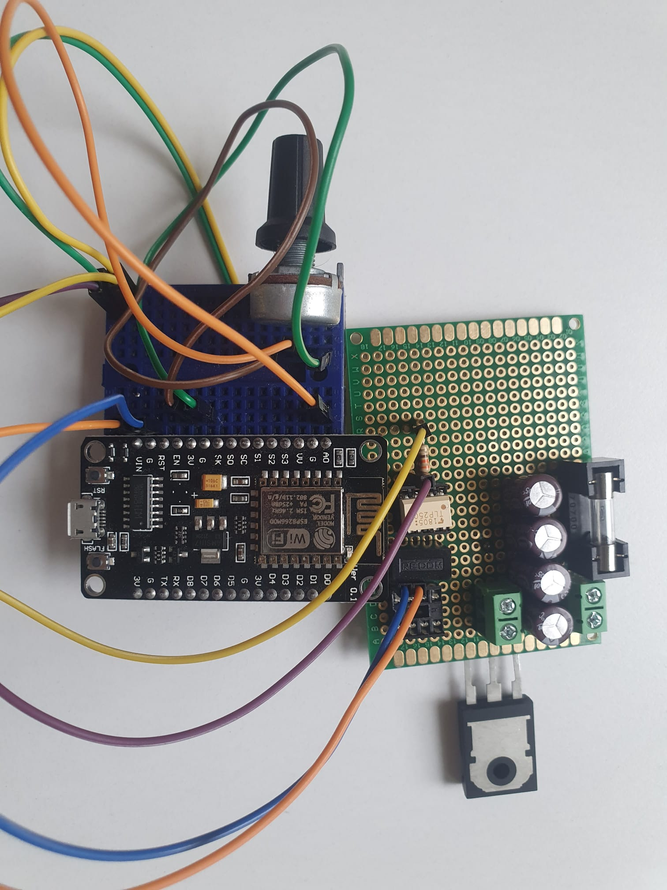

Figure 9: Buck Converter Circuit

Figure 9 show Buck Converter implementation, which is failed since in the simulation, capacitors don’t draw current. As a result, values are miscalculated.

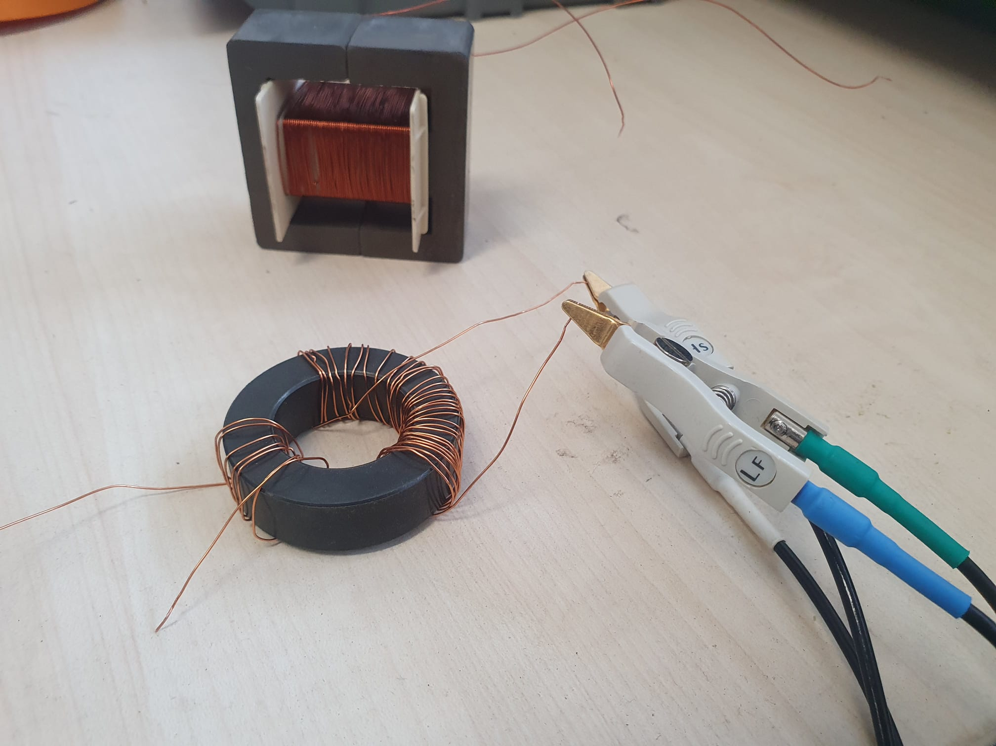

Figure 10: Manually Wounded Transformers

Figure 10 shows the transformer prototypes. Both transformers are failed. Toroidal core transformer is failed since inductance of the transformer is very small, which can be seen from Figure 11.

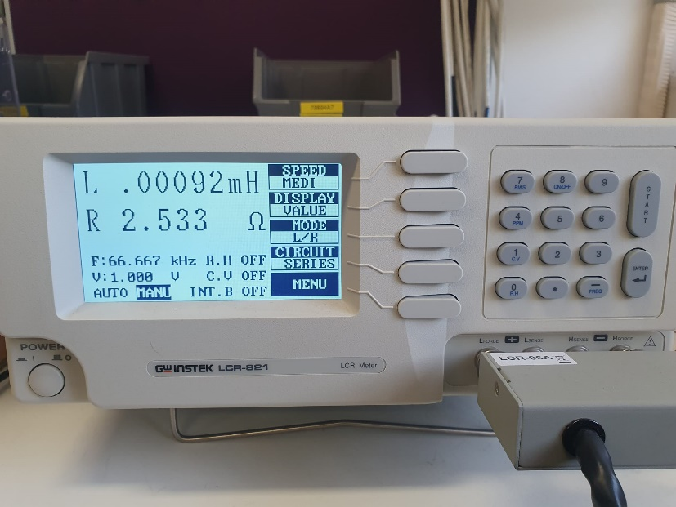

Figure 11: Inductance measurement of Toroidal Core Transformer

Even though the E core has higher number of windings, it stills draws very large current as shown in the Figure 12.

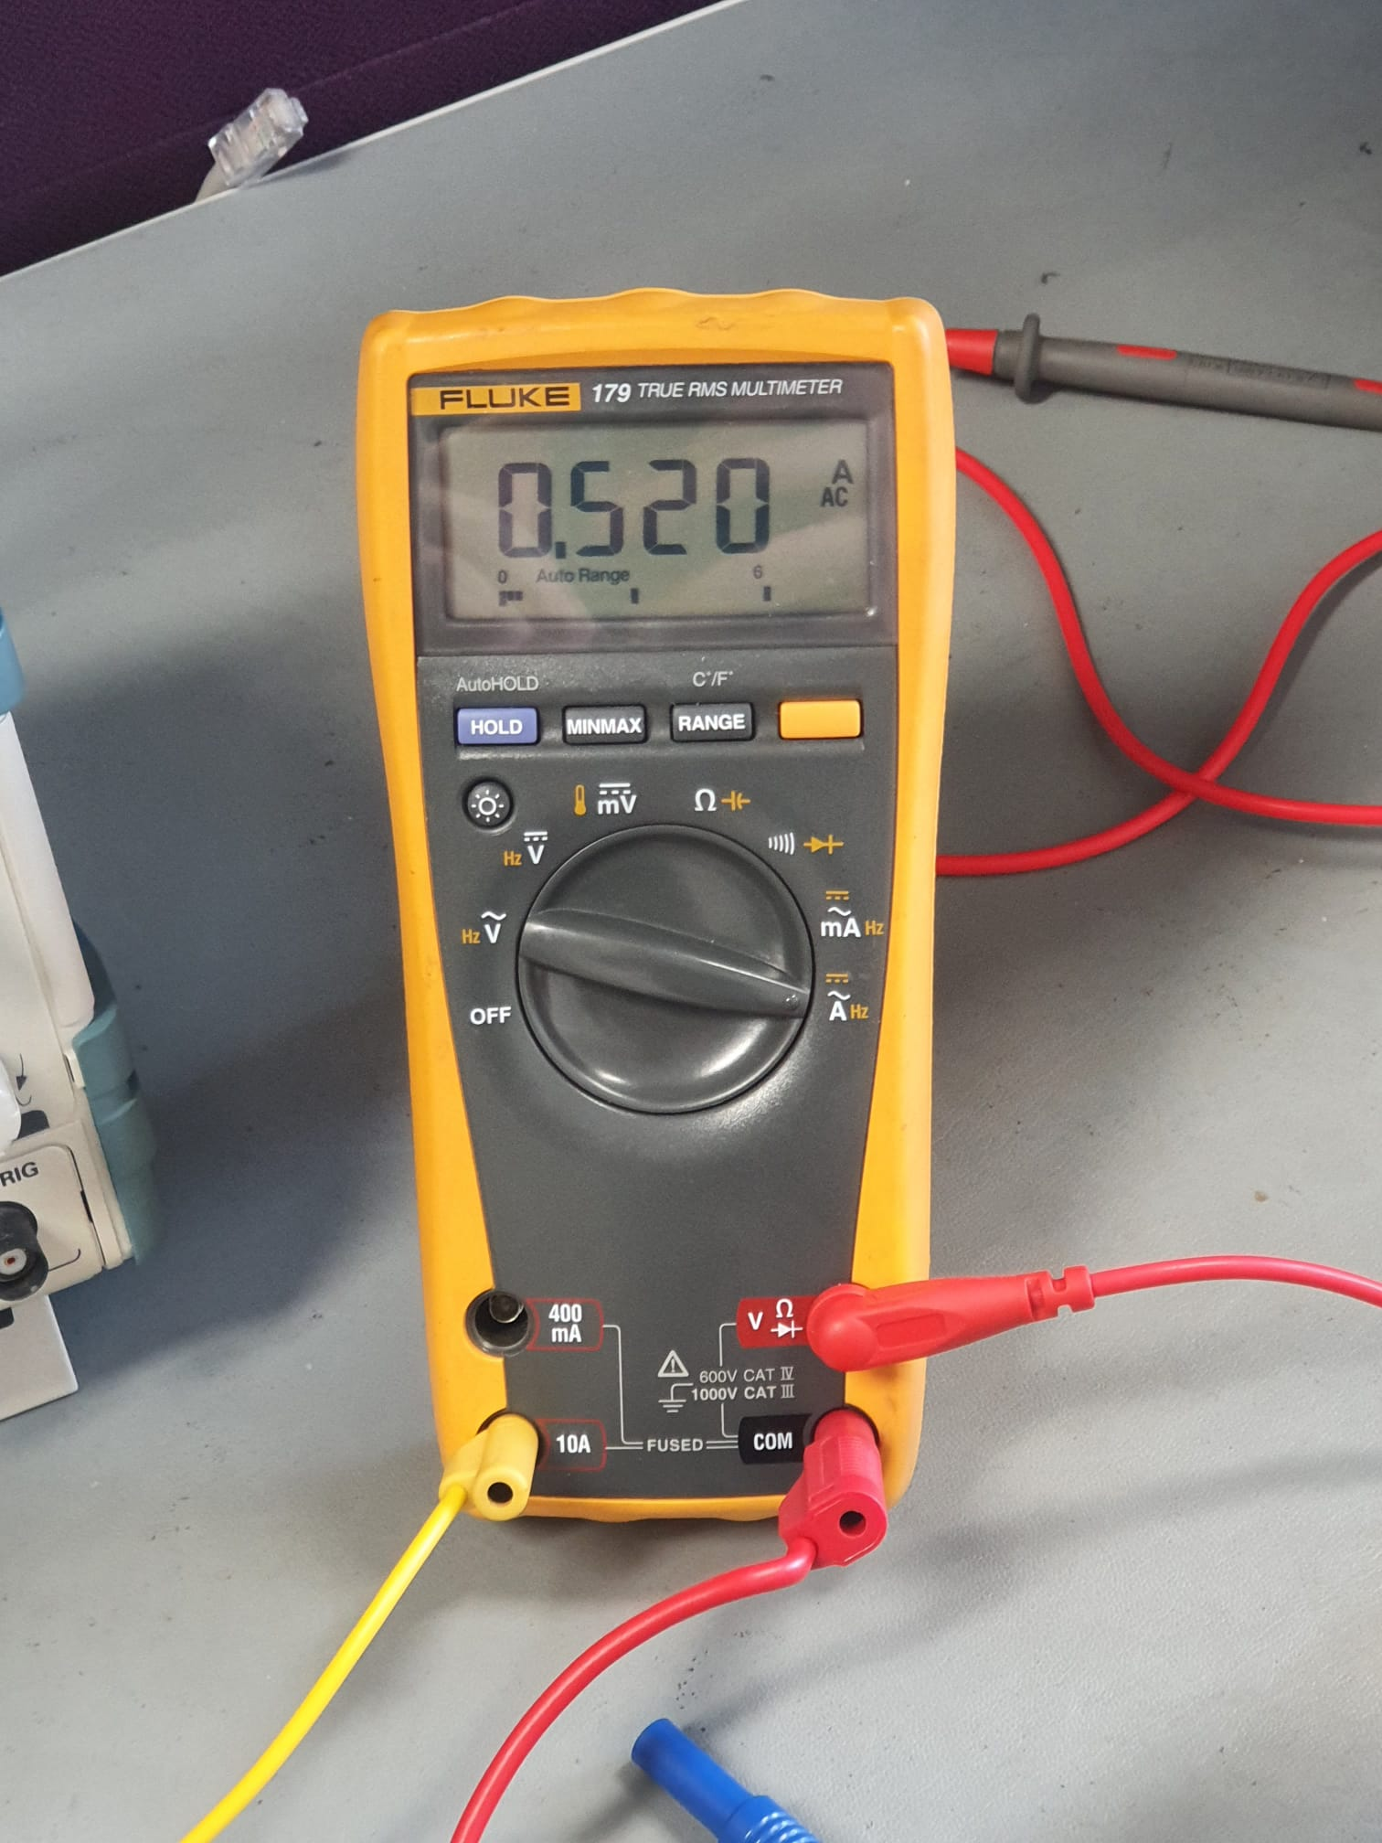

Figure 12: Current Measurement of Primary Side of E Core Transformer

Results of the experiments shows that more professionally designed transformed is required for step down transformer.

## Conclusion

In this report, bonuses, which effect the design of the project, topology and its explanation, component selection steps and experimental results are provided. Next step of the project is overhauling the miscalculated component parameters and construct the base circuitry, which is one quadrant simple MOSFET drive. Then, OpAmp circuities will be designed for current loop and H bridge four quadrant operation.

# References

|  |  |
| --- | --- |
| [1] | C. AUTOMATION, "CANTHO AUTOMATION," 26 04 2022. [Online]. Available: https://canthoautomation.com/three-phase-full-wave-controlled-rectifier/. |